**Swagger Endpoints**

**Unit Tests**

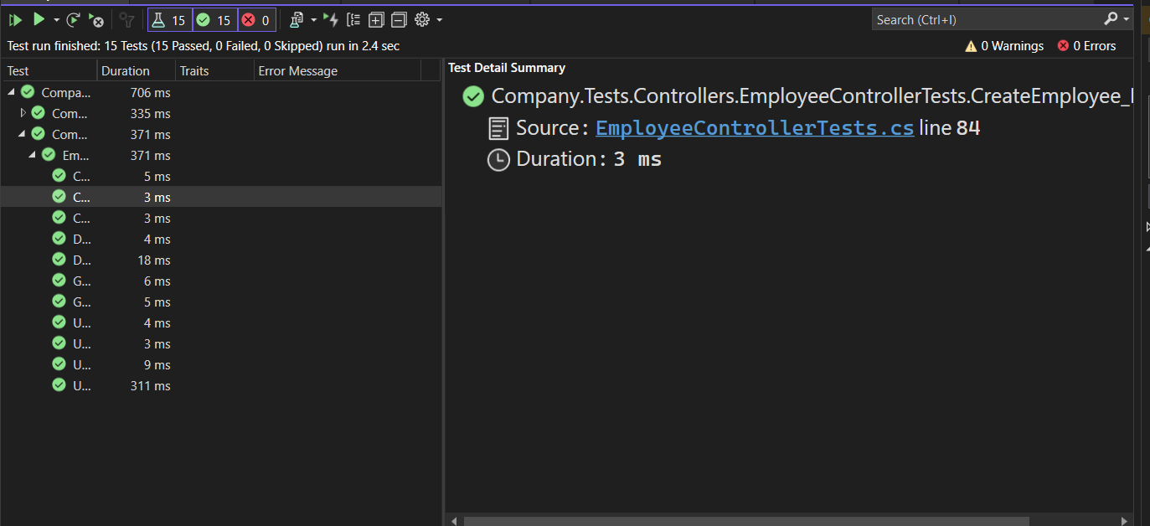

**Database**

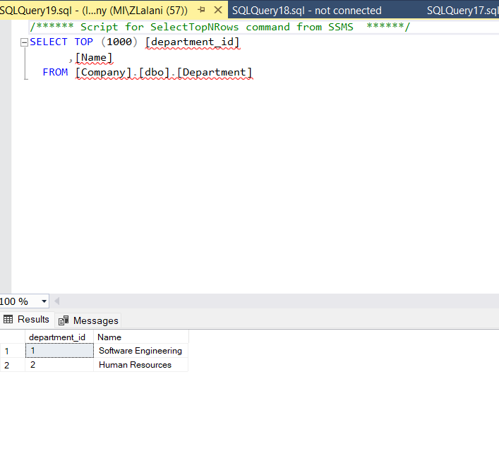

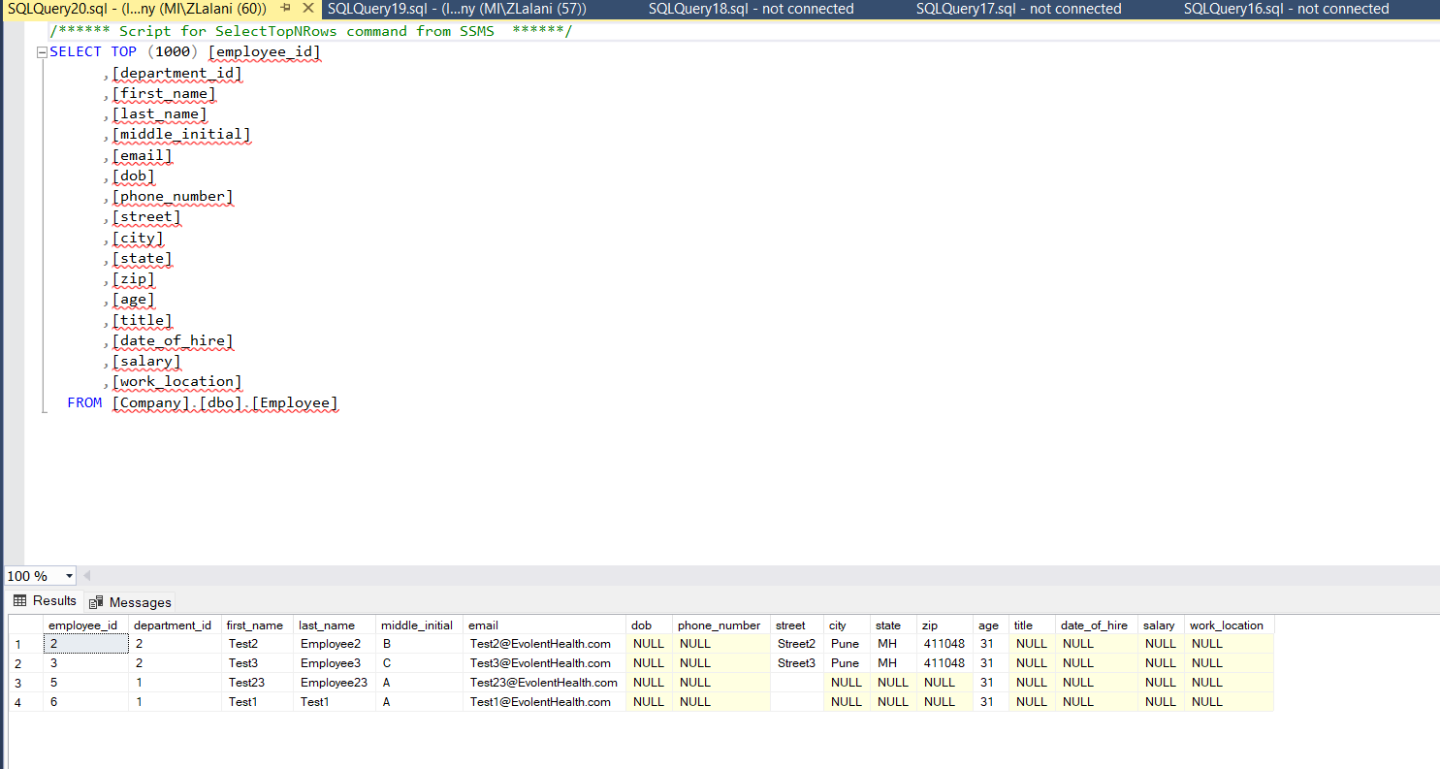

**Employees**:

**Getting Seeded Employees by id**

**Getting All Employees with their departments and address**

**Posting Employee**

**Deleting an employee**

**Getting Seeded Department By ID**  
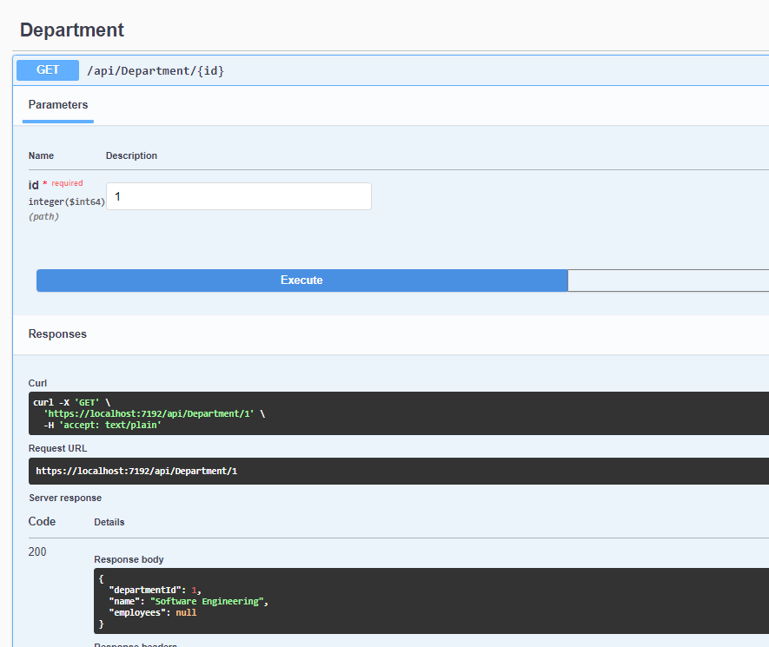

**Getting All Departments**

**Posting Department**

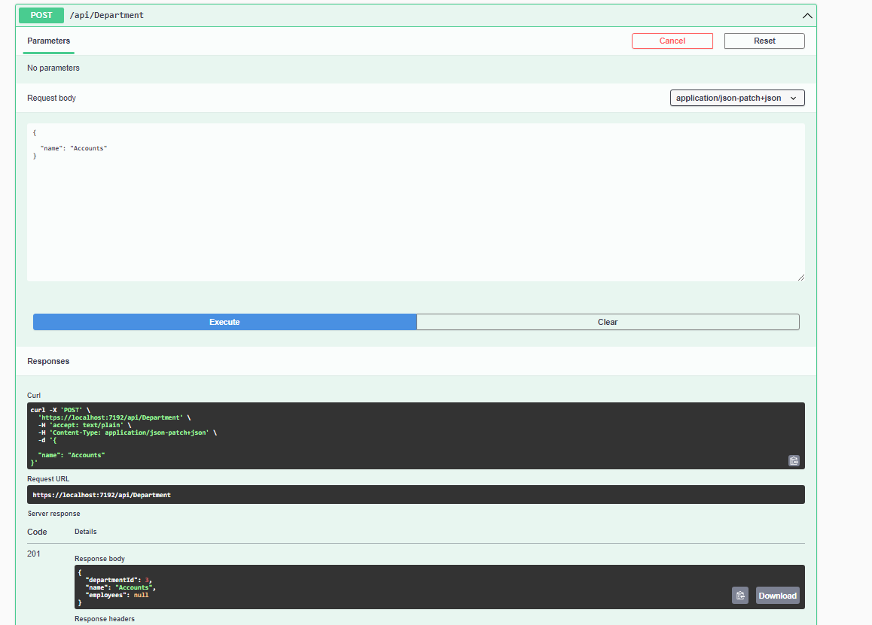

**Updating Department**